Introduction to Electrical Engineering

Assignment #9

Javier Jesús Macossay-Hernández

Student ID: #20228488

Tuesday, March 19, 2013

Problem 1:

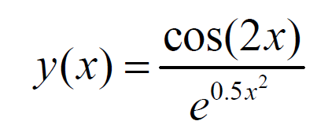

MATLAB Script:

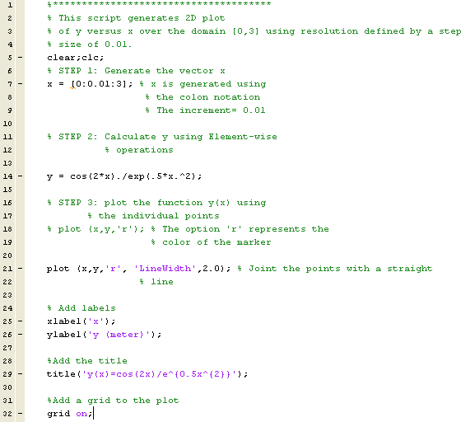

Generated plot:

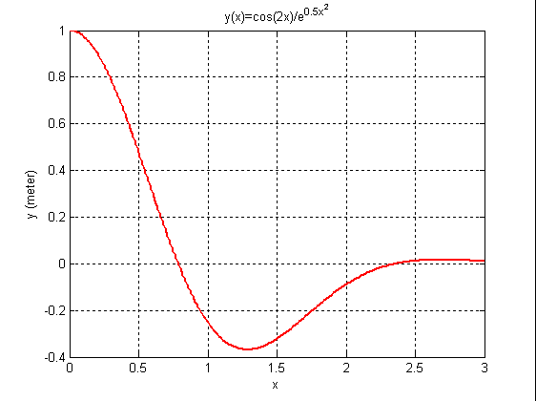

Problem 2:

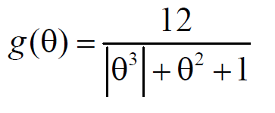

MATLAB Script:

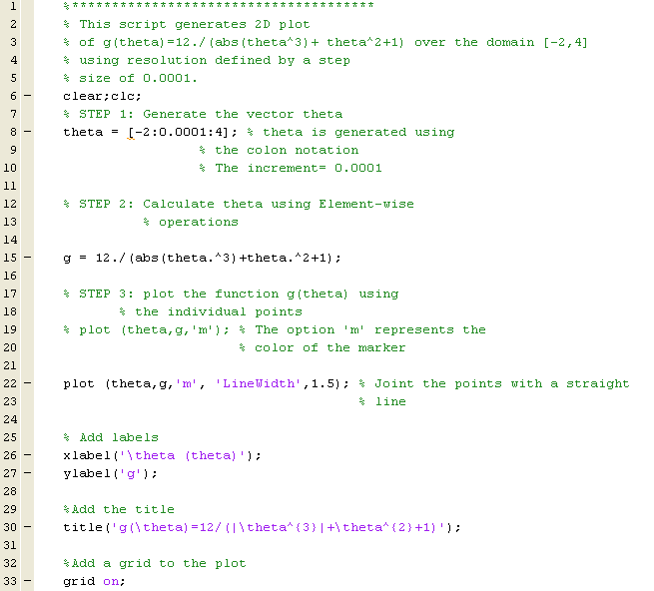

Generated plot:

